**Design Phase-2**

**Data Flow Diagram & User Stories**

|  |  |
| --- | --- |
| **Date** | 15 October 2022 |
| **Team ID** | PNT2022TMID10394 |
| **Project Name** | Gas leakage monitoring and alerting system for industries |
| **Maximum Marks** | 4 Marks |

**DataFlow Diagram:-**

* A Data Flow Diagram (DFD) is a traditional visual representation of the information flows within a system. A neat and clear DFD can depict the right amount of the system requirement graphically. It shows how data enters and leaves the system, what changes the information, and where data is stored

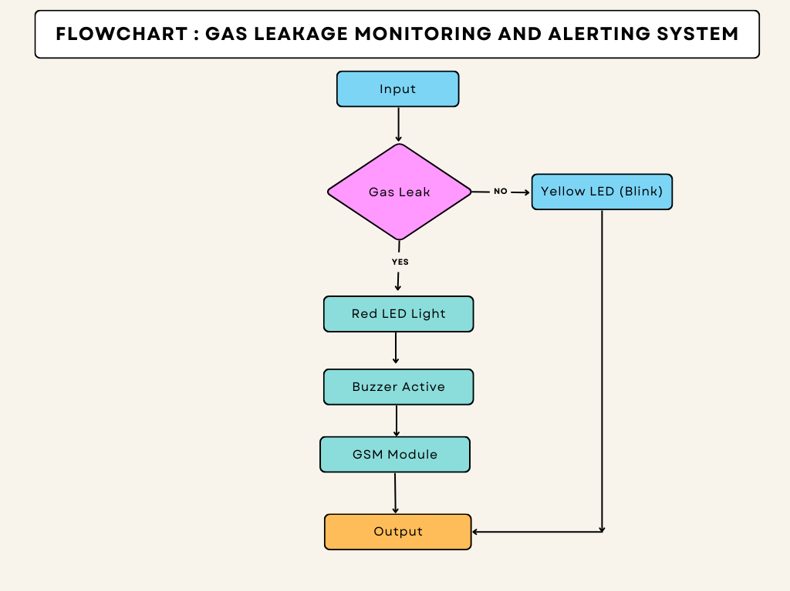

**User Stories:-**

|  |  |  |  |  |  |  |
| --- | --- | --- | --- | --- | --- | --- |
| **User Type** | **Functional Requirement (Epic)** | **User Story Number** | **User Story / Task** | **Acceptance criteria** | **Priority** | **Release** |
| Customer(family member/industry owner) | Registration | USN-1 | As a user, I can register for the device in the owner’s mobile application by entering my email and password | I can access my account/dashboard | High | Sprint-1 |
| Customer(higher authority) | Confirmation | USN-2 | As a user, I will receive a confirmation message via email and once I received I can install the device in the owners place | I can receive a confirmation email & click confirm | High | Sprint-1 |
| Customer (fire service 101) | Safety measure register | USN-3 | As a register, I canregister the application in the owner/family members mobile phone | I can register & access the dashboard with Facebook Login | Low | Sprint-2 |
| Customer (mobile user) | Mobile application | USN-4 | As a user, I can register by mobile application | I can register for a gas detection device with the owner’s mobile number. | Medium | Sprint-1 |
| Customer (credential) | Login | USN-5 | As a user, I can login to the device by entering my email & password in the owner’s mobile application | Mail addresses and passwordsare the default | High | Sprint-1 |
| Customer (Web user) | Notification | USN-6 | As a user when there is a critical situation regarding a gas explosion the alert notification will be received through GSM module | The alert message is sent to the owner’s mobile as an SMS. | High | Sprint-1 |
| Customer care Executive | Network Connectivity | USN-7 | As a user when there is a critical situation regarding a gas explosion the alert notification will be received through GSM module | The sensor detects the leakage andnotifies the owner via message | High | Sprint-1 |
| Administration | Accessing | USN-8 | When there is an issue in accessing the device | When there is an issue in accessing the device | High | Sprint-1 |